Seabird Food Chain Relay Race
By Kendra Bush-St. Louis
Alaska Maritime National Wildlife Refuge

Objective: Students will engage in a relay race style game to complete a seabird food chain.
Materials:
- 5 Station signs (sunlight and nutrients from seabird guano, producers, primary consumers, secondary consumers and tertiary (top) predators)
- 5-6 photos at each station to represent that trophic level within a seabird’s food chain
- 5-6 game boards for the students to assemble their food chain on
(You can design these materials however you like. There are pictures attached to the end of this document to show how AK Maritime Refuge designed the game pieces.)
Set Up:
The play area should be set up in the following way:

Primary Consumers
Team 1
Sunlight and Nutrients
Team 2
Secondary Consumers
Team 4
Team 3

Producers
Team 5
Team 6
Tertiary Consumers

Randomly set out the 5 trophic level station signs in the playing area. Each station will get 5-6 photos representing that trophic level within the seabird food chain.
Game Rules:
- Split the players into groups of 5. Have the teams line up in a single file line facing the playing area.
- Give each team a game board and explain to them that they have to fill in each portion of the board using a photo they collect from each of the different trophic levels in the playing area.
- When the instructors yells “go”, the first person in the line will run to the first trophic level and collect one photo to bring back and place on their game board. Once their photo is placed on the game board, the next person in line is able to go. Only one person from each team can go at a time. Once a team’s entire game board is complete, they can signal the instructor that they have completed their board. (Be sure to stress to the students that their seabird food chain has to make sense. For example, a least auklet will not be catching small feeder fish to eat.) If their food chain does not make sense, it does not count as a completed board.
- The first team to successfully complete their board wins the relay race.

Photos of Alaska Maritime National Wildlife Refuge Game Pieces:
-5 Station Signs-
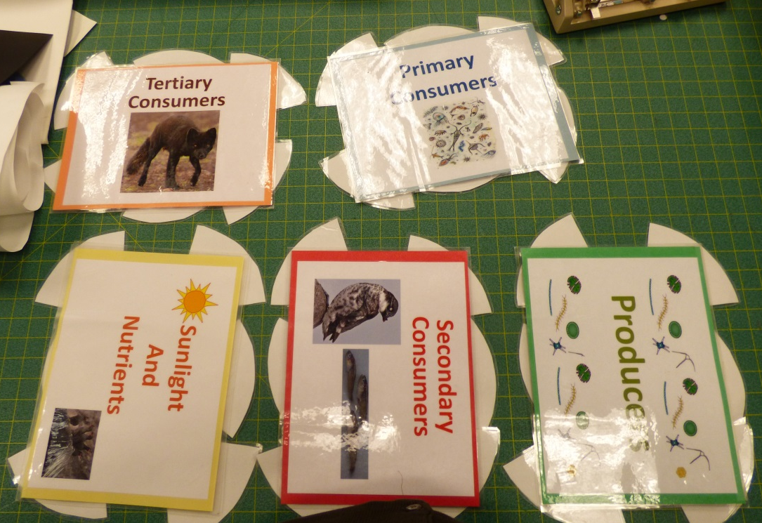
-Samples of game board pieces/ photos representing each trophic level-
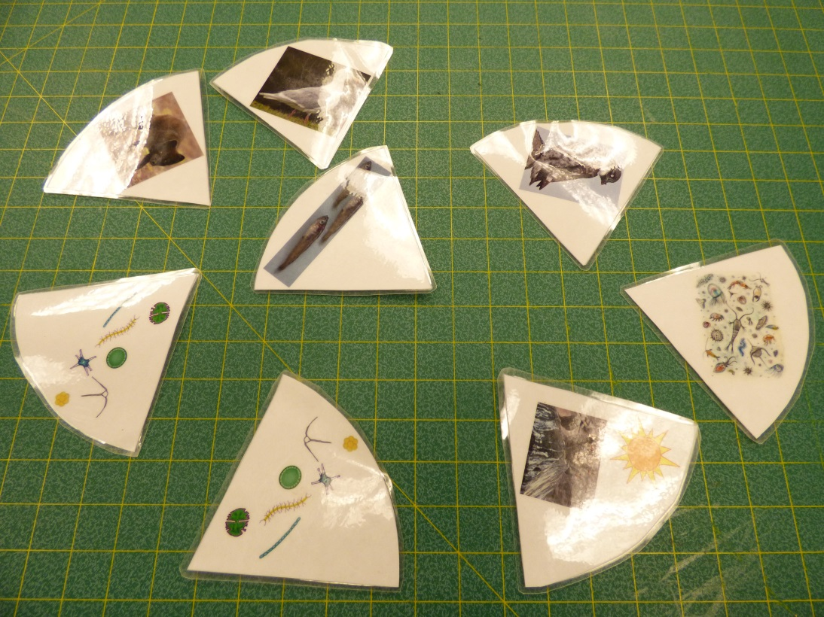
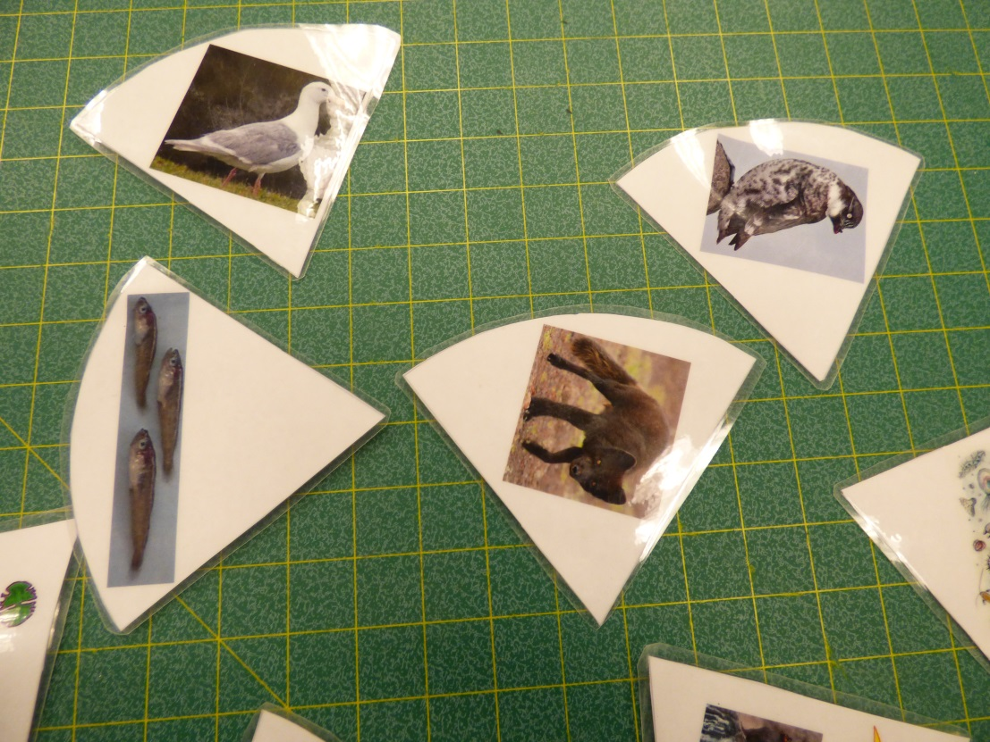

-Game Board-
