Finally! Red-legged Kittiwakes found to feed at night.
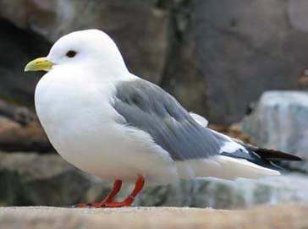
http://www.neseabirds.com/NorthAmer/alaska2005p1.htm
Researchers: Nobuo Kokubun, Takashi Yamamoto, Dale M. Kikuchi, Alexander Kitaysky, and Akinori Takahashi

Study Summary:
The red-legged kittiwake is a seabird that lives only in the Bering Sea. They are a small gull with red legs, a short yellow beak, and very large black eyes. They are very cute. Their call “Kitti-waake! Kitti-waake!” sounds like they swallowed a squeaky toy. Every summer they return to their colonies on islands in the middle of the ocean to lay eggs and raise their chicks.
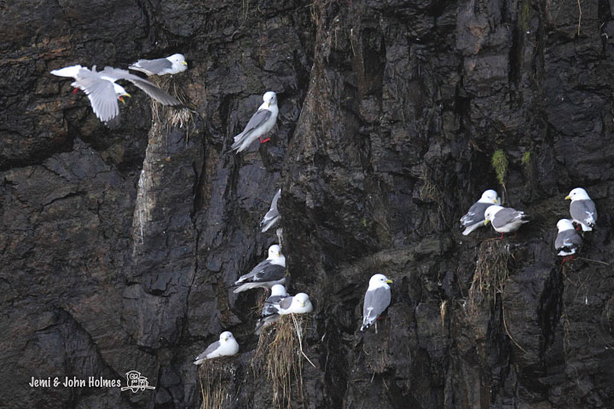
Researchers have long thought that during the summer red-legged kittiwakes are nocturnal surface feeders. They thought that the birds’ large eyes were for finding fish at night. Nighttime feeding would also explain how red-legged kittiwakes, a bird that does not dive, captures deep-water lampfish (myctophids) to feed to their chicks. At night lampfish migrate vertically to feed near the surface of the ocean, where red-legged kittiwakes can reach them.
But, there was a problem with this story: no one had ever documented a red-legged kittiwake feeding at night! Dr. Kokubun and his colleagues conducted a study to characterize the foraging behavior of chick-rearing kittiwakes. They set out to describe the type of habitat where red-legged kittiwakes captured lampfish to feed their young.
Dr. Kokubun used small GPS tracking devices to find out where birds were going. He also used motion detecting devices that recorded wing beats and body position. Dr. Kokubun used these tags to tell when birds were flying, resting, or feeding. Dr .Kokubun’s team attached these data-loggers to the study birds’ tail (GPS tag) and belly (movement tag) using a special tape, called Tesa tape, that sticks to itself but that can be peeled off feathers. He caught birds using a “noose-pole”. A noose pole is a long pole with a noose at the end. Researchers slip the noose over the bird’s neck then pull them in. The noose is made out of thick line and does not hurt the bird’s neck.
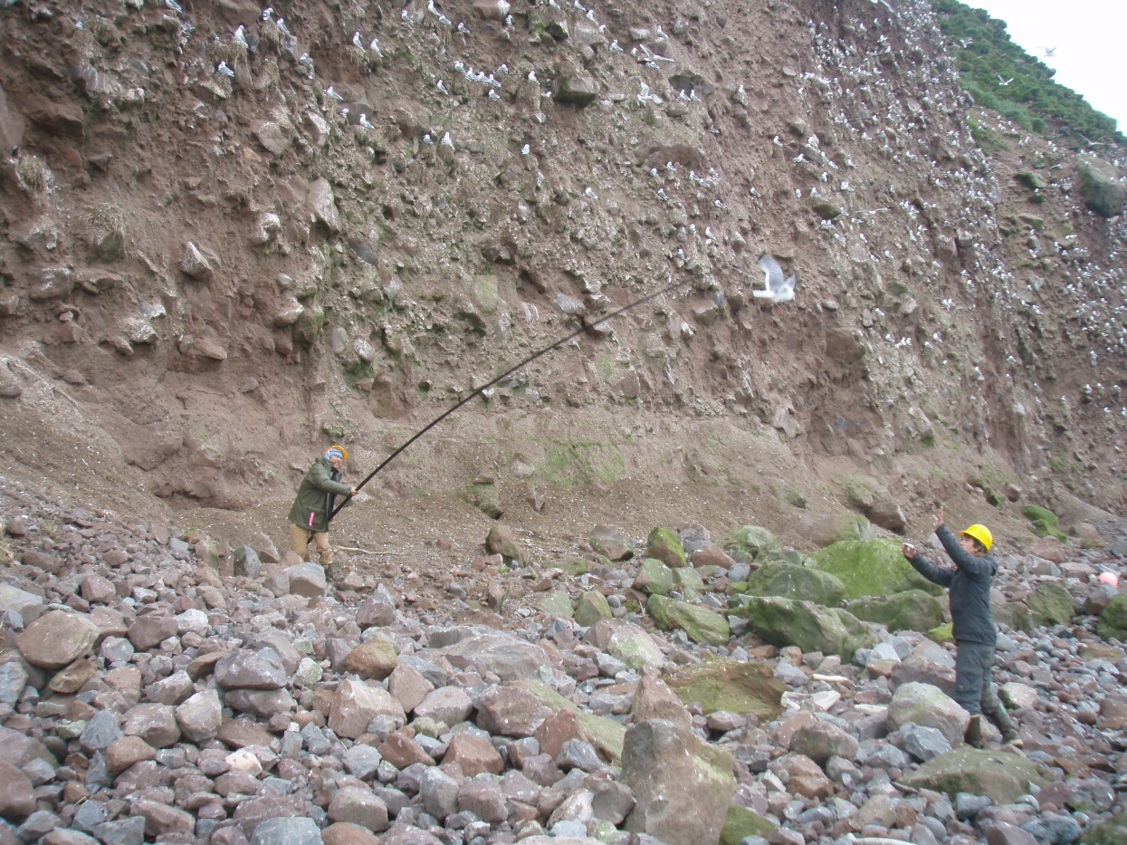
Alexis Will
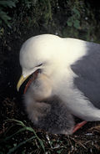
When red-legged kittiwakes are scared they will regurgitate or puke up whatever is in their belly. This is also how they feed their chicks. When researchers catch birds they are scared, they puke, and the puke is collected to find out what kinds of fish the birds were catching. Fish have earbones called otoliths that are like a species-finger print. Each species of fish has a different shaped otolith. These earbones are very tough and do not digest easily. Dr. Kokubun and his team sorted through the puke to find these hard parts and used them to identify what fish species the birds were eating.
Alexis Will
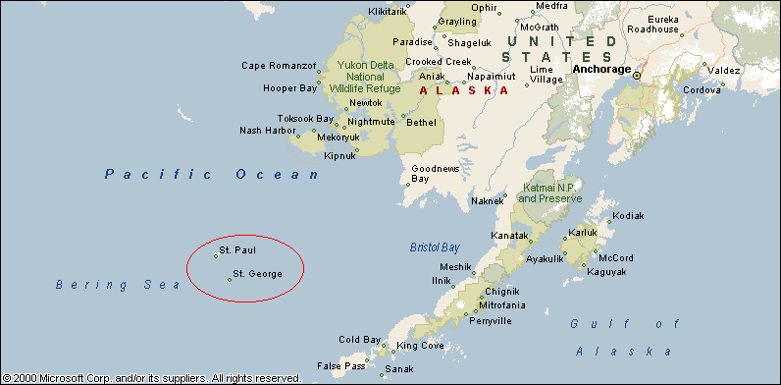
Dr. Kokubun’s team captured birds on St. George Is. during July and August of 2013. St. George Island is part of the Pribilof Islands located in the southeastern Bering Sea. Dr. Kokubun’s team obtained GPS tracks from 15 individuals and movement patterns from 7. Unfortunately, due to technical difficulties only 5 of the GPS tags recorded data.
Dr. Kokubun found that the movement devices recorded more flying behavior at night than during the day. This behavior matched GPS locations that were recorded in the open ocean at the same time. They also found that myctophids (lampfish) dominated the diet. These results support the long-held belief that chick-rearing red-legged kittiwakes are specialized to search for and feed on myctophids at the sea surface during nighttime in the oceanic basin of the Bering Sea. Now we know!

