Flesh-footed Shearwaters are eating too much plastic.

Research by: Jennifer L. Lavers, Alexander L. Bond, Ian Hutton

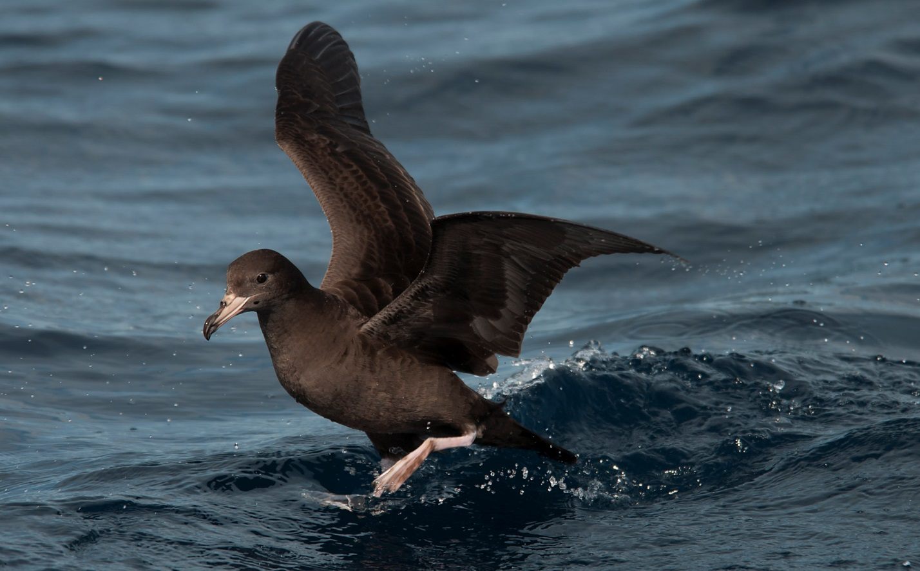
Phillip Griffin

Flesh-footed shearwaters nest in Eastern Australia. Shearwaters eat small fish and often will eat the bait that fishing boats use to catch fish. They nest on islands where they dig tunnels into the soil and lay a single egg. Once the egg hatches both parents feed their chick for 92 days. When the chick is about 92 days old it is ready to leave the nest and head out into the world alone.
The flesh-footed shearwater populations in Eastern Australia have been declining, each year there are fewer birds returning to the colony. Jennifer Lavers and her fellow scientists noticed that some of the shearwater chicks were dying. They examined the carcasses for clues as to why, and discovered that there was a surprising amount of plastic in the dead birds’ stomachs. They conducted a study to answer the question: are plastics harming shearwater chicks?
In 2011 they collected their data. They captured chicks as they were fledging, when they leave their nests and fly away from the colony. This is not difficult to do because shearwater chicks leave the colony at night and have to walk to a place where they can take off from. All the researchers have to is, be stealthy and grab the chicks by hand! Once they captured a chick they measured its wing length, head length, and body mass. They also collected 4 breast feathers and they did a stomach sampling technique called water-offloading or lavage, which causes birds to vomit the entire contents of their stomach.
Ms. Lavers and her colleagues found that many of the birds had plastic in their stomach and that most of the plastics were white. Over half (60%) of the birds had quantities higher than levels considered to be “safe.” On average birds had 17 pieces of plastic in their stomachs, but some had even more. One small bird had 276 pieces in its stomach; the plastic made up 14.4% of its body weight! They found that birds with more plastic in their stomach had shorter wing lengths and weighed less.

The feathers that Ms. Lavers and her team collected were analyzed for harmful elements. Her team wondered whether plastic could be poisoning the chicks. They found that chicks that had more plastic in their stomachs also had higher concentrations of Chromium and Silver in their feathers. These types of metals can have damaging effects on brain function.
Ms. Lavers and her team concluded that plastics are having a negative impact on the ability of flesh-footed shearwaters to successfully raise their young. They found that plastic can not only cause physical damage to internal organs, but the quantity of plastic can interfere with the ability of young birds to grow, and may also pose long-term neurological (brain) problems if birds continue to ingest plastic as adults.

Questions to pose:

Shearwaters--

What is 14% of your body weight?

Why do you think that birds that were fed more plastic did not grow as big as other birds who had been fed less plastic?

Why do you think that shearwaters are eating plastic?

Is there any reason that they might eat more white plastic than other types?

What other sea creatures might mistake plastic for their food?

Turtles— this article is on the next page.

What are some of the challenges a sea turtle might face during its lifetime?

Mistaken Identity? Are turtles eating plastic because they think it’s food?

Researchers: Qamar A. Schuyler, Chris Wilcox, Kathy Townsend, B. Denise Hardesty, and N. Justin Marshall

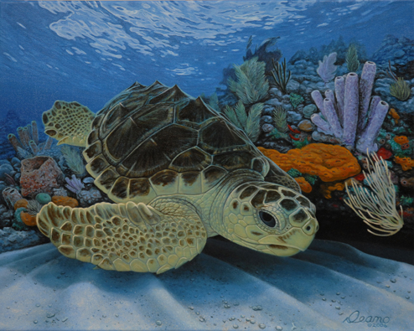

Sea turtles face a lot of challenges during their life. Many are long-lived, large, and travel great distances. Recently humans have introduced a new challenge: plastics in the ocean. Sea turtles have started to die from eating plastic, which they are unable to digest. They feel full but starve. Why is this? A team of scientists led by Qamar Schuyler thought it could be one of two reasons. 1) Turtles are mistaking marine debris for food, or 2) they are opportunistic and eat whatever they encounter, whether it is debris or jellyfish floating in the ocean.
To find an answer to their question Schuyler’s team built a model of the sea turtle’s visual system. This allowed them to “see” like a turtle. Using this system they examined marine debris found in the stomachs of dead turtles and their main prey, jellyfish. They compared the images and found that the marine debris in the turtle’s stomachs look just like jelly fish.
Qamar and his team concluded that sea turtles are eating marine debris because it looks like jellyfish to them.
Sharon Milne

